***ECONOMIC FREEDOM ANALYSIS***

**1.Introduction**

**1.1 overview**

Economic freedom is the fundamental right of every human to control his or her own labor and property. In an economically free society, individuals are free to work, produce, consume, and invest in any way they please. In economically free societies, governments allow labor, capital, and goods to move freely, and refrain from coercion or constraint of liberty beyond the extent necessary to protect and maintain liberty itself. For much of human history, most individuals have lacked economic freedom and opportunity, condemning them to poverty and deprivation.

**1.2 Purpose**

Today, we live in the most prosperous time in human history. Poverty, sicknesses, and ignorance are receding throughout the world, due in large part to the advance of economic freedom. In 2022, the principles of economic freedom that have fueled this monumental progress are once again measured in the Index of Economic Freedom, an annual guide published by The Heritage Foundation, Washington's No. 1 think tank. We measure economic freedom based on 12 quantitative and qualitative factors, grouped into four broad categories, or pillars, of economic freedom: 1) Rule of law property rights, government integrity, judicial effectiveness) 2) Government size (government spending, tax burden, fiscal health) 3) Regulatory efficiency (business freedom, labor freedom, monetary freedom) 4) Open markets (trade freedom, investment freedom, financial freedom)

**2. Problem defining and desing thinking**

**2.1**

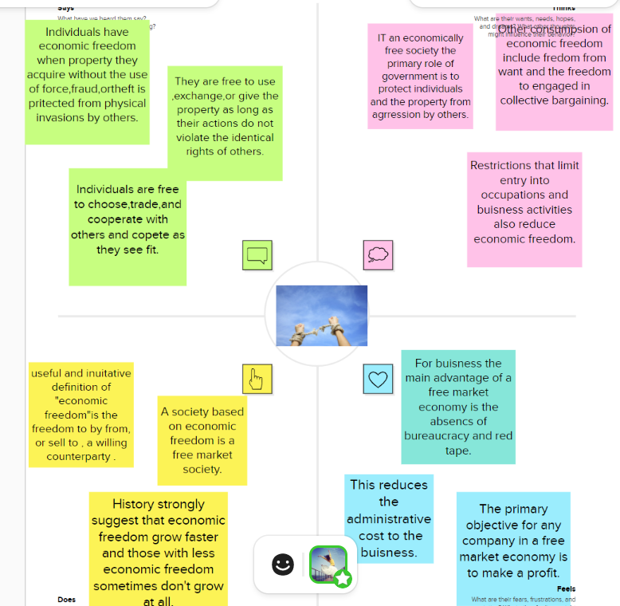

**2.2 Identation and brainstorming**

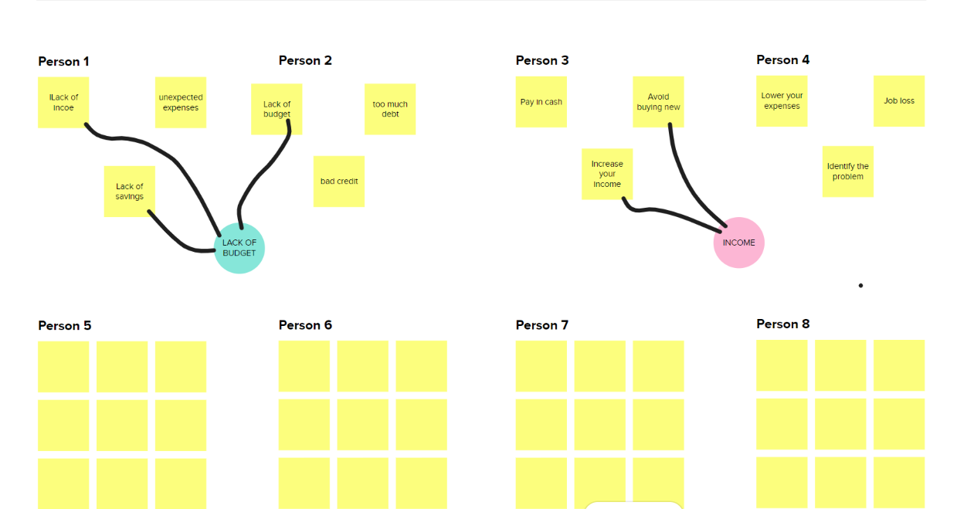

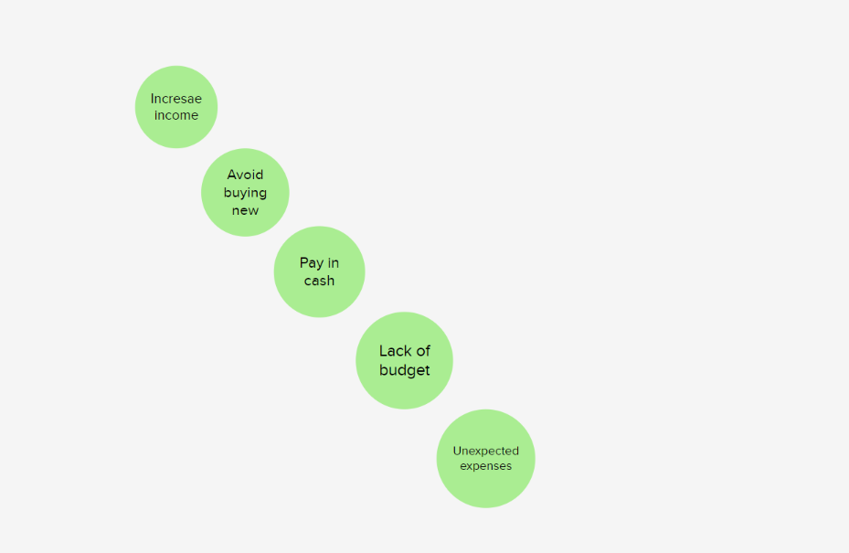

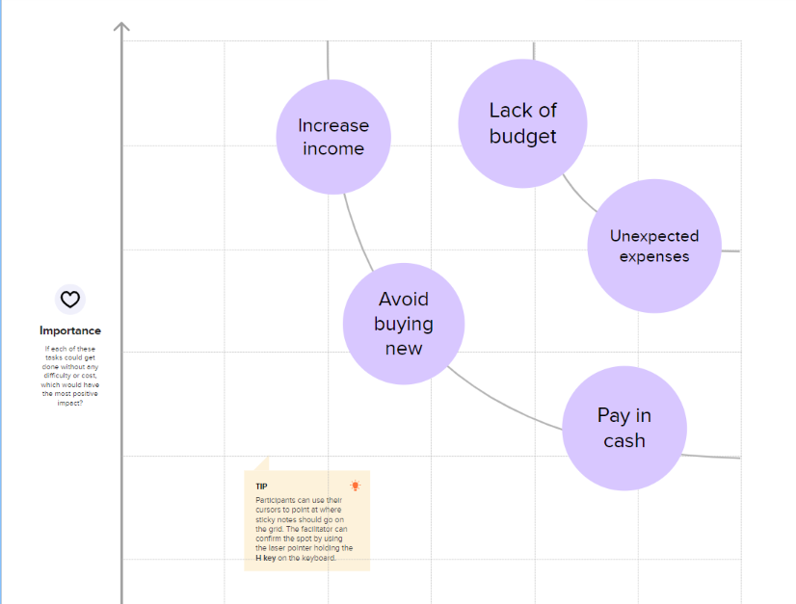

3.**RESULT**

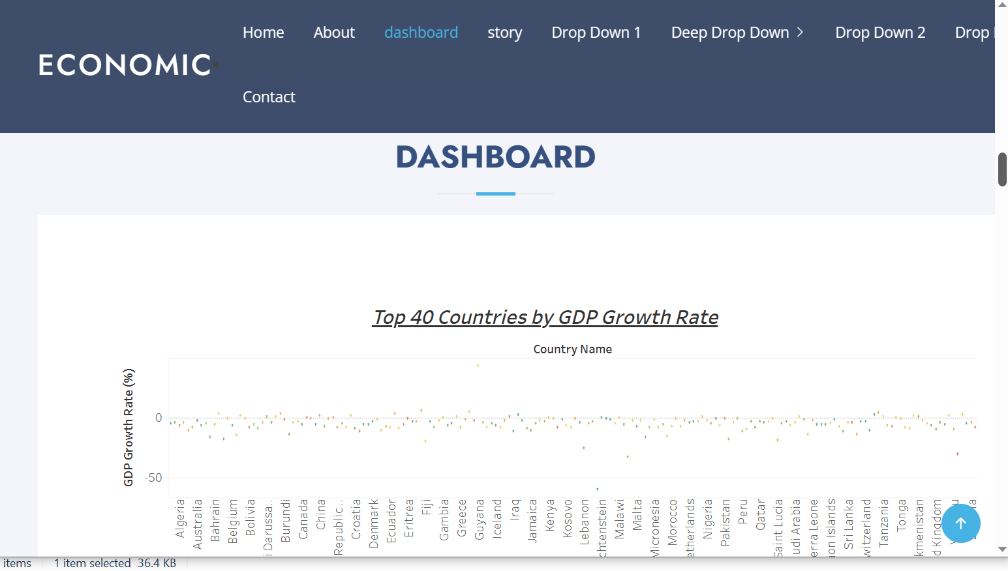

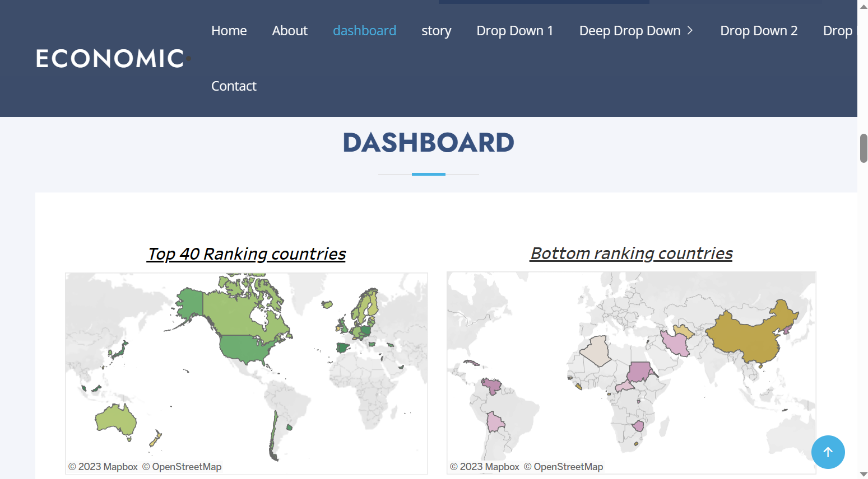

**4.Advantages**

* Increased efficiency
* Production
* Innovation
* Money generated such as Net income
* Revenues

**DISADVANTAGES**

* Unemployement
* Inequality
* Excessive power of firms
* Poor Quality
* Intense competition
* Economic disparities

**5.APPLICATIONS OF ECONOMIC FREEDOM**

The cornerstones of economic freedom are

(1) Personal choice

(2) voluntary exchange coordinated by markets

(3) freedom to enter and compete in markets and

(4) protection of persons and their property from aggression by others.

**CONCLUSION**

It helps us to make sure that each member of the team has a specific role and responsibility that team members are compatible with each other and can work together harmoniously.

Mainly it is very useful to save the economic income and prosperity.

**FUTURE SCOPE**

Generally startups in India are expected to raise USD180 billion in 2023,with a growing economy,

 The key ingredients of economic freedom are **personal choice, voluntary exchange, freedom to compete in markets, and protection of person.**

**APPENDIX**

**SOURCE CODE**

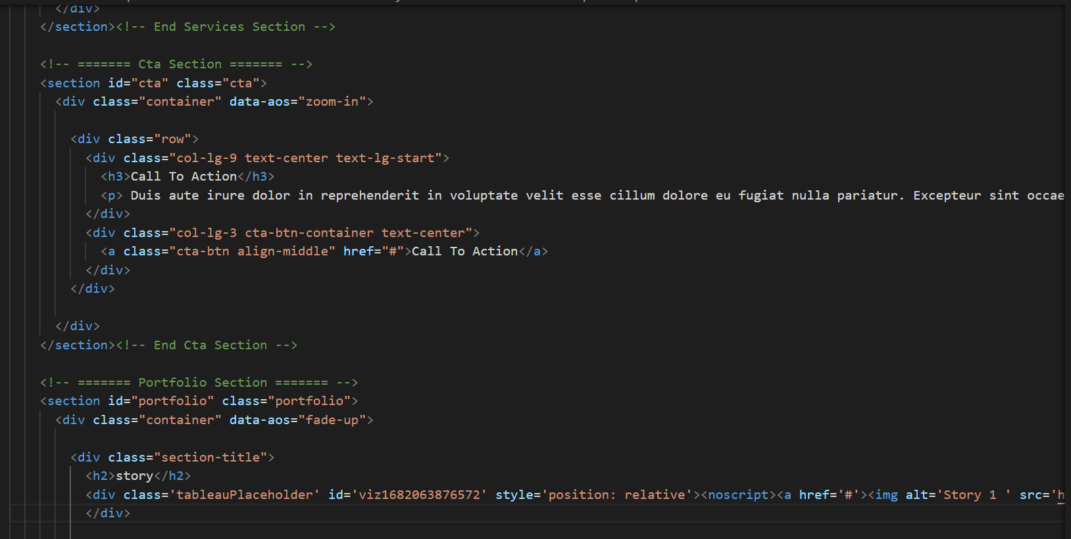

ghb

